(Approx. 459 words)

Back to the Basics
Do you know these Google Icons?
By Jim Cerny, Forum Leader, Sarasota Technology Users Group, FL
May 2019 issue, The STUG Monitor
www.thestug.org / jimcerny123 (at) gmail.com

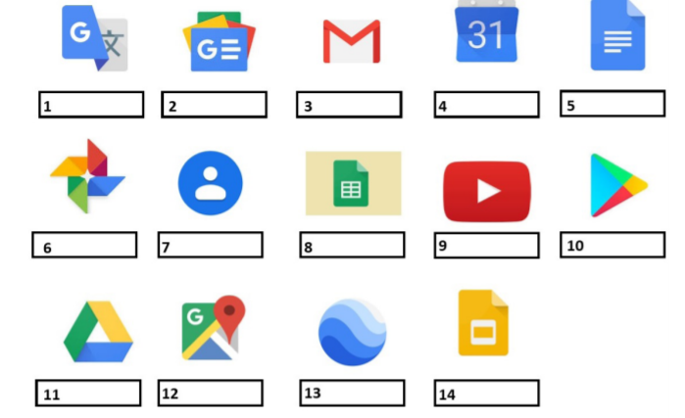
The above icons represent some popular Google apps, do you recognize any of them? Write the name of the app in the box. All these apps are FREE with Google, all you need is a Google account. Still stuck on a few? Maybe you can match a description below to the icon above. Of course they are not in the same order, what would the fun be in that? (The answers are at the end of this article).

A— Google Earth -- Explore anyplace on the planet, zoom in or out, take tours, and enjoy the constantly improving 3D buildings and land formations. Absolutely dazzling!
B — Google DRIVE – Free software that works like Microsoft Office – you get Google Docs (word processing), Sheets (spreadsheets), Slides (presentations) and more. You can also put (upload) ANY of your files onto the drive to share with others and have them available anywhere. There is a small charge if you exceed the free 15 GB space amount.
C — YouTube – Now in the Google family. Search and find videos on ANY topic or any famous person. See videos from the past or from other countries. Great for entertainment! When you do a Google search on the internet you will most likely be presented with several videos. It is amazing the free videos you can find on YouTube!
D — Google MAPS – A great way to travel and get from place to place. Probably better than the map software used in your car. Plan your travels and compare alternate routes. E — Google Translate – Translate from one language to another, super easy and super fun!
F — GMAIL – A great email app to do your email on all your devices.
G — Google Play – Entertainment access to movies, TV shows, books, music, and much more. Download or use charges may be applied.
H — Google PHOTOS – Use the camera on your smart phone and your photos will be uploaded to Google Photos for you, freeing up space on your device. Now you can see and work with your photos on any device.
I — Google Calendar – Keep all your appointments here. Can be synced to your iPhone.
J — Google Sheets (part of Google Drive) – Free word processor similar to Microsoft Word.
K — Google Contacts – One place for all your contacts. Can be synced to your iPhone. L — Google News – A great source for news.
M — Google Slides (part of Google Drive) – Free presentation app for creating great slides for your talk similar to Microsoft PowerPoint.
N — Google Docs (part of Google Drive) – A great free word processor similar to Microsoft Word.

